Statistical Analysis and Hypothesis Testing
A Multi-Test Investigation of the JFK Airport Weather Record (2010–2018)

Week 3 Deliverable — Statistical Analysis & Hypothesis Testing in Python
Dataset: NOAA Local Climatological Data — JFK International Airport
Tools: Python 3, Pandas, NumPy, SciPy, Statsmodels, Matplotlib, Seaborn

1. Executive Summary
This report investigates four business- and science-relevant hypotheses about weather behaviour at John F. Kennedy International Airport (JFK) using more than 114,000 hourly meteorological observations collected between January 2010 and July 2018 by the National Oceanic and Atmospheric Administration (NOAA). The analysis combines classical parametric tests (Welch's t-test, one-way ANOVA with Tukey HSD post-hoc, Pearson correlation) with a non-parametric independence test (Pearson's chi-square). All four null hypotheses were rejected at the α = 0.05 significance level, but the magnitude of practical significance varies substantially — from very large (temperature seasonality, Cohen's d ≈ 4.36) to small (temperature–humidity correlation, r ≈ 0.12). The findings have direct operational value for aviation scheduling, ground-operations staffing, and energy-demand forecasting at JFK.

2. Introduction and Business Context
JFK is one of the busiest airports in the world. Weather conditions directly translate into delays, fuel-burn penalties, and safety-related decisions. Airlines, air-traffic controllers, ground-services vendors and energy providers at the airport need statistically defensible answers to seemingly simple seasonal questions: Are winters truly colder in a measurable way? Is wind speed materially different across seasons? Are low-visibility events concentrated in certain seasons? Do temperature and humidity move together? This report treats each question as a formal statistical hypothesis and applies the appropriate test.

3. Data Description
The dataset (jfk_weather_cleaned.csv) contains 114,544 hourly observations with 16 meteorological variables. Key fields used in this analysis are:
Variable | Description | Unit
DATE | Timestamp of observation | YYYY-MM-DD HH:MM:SS
dry_bulb_temp_f | Ambient (dry-bulb) air temperature | °F
wet_bulb_temp_f | Wet-bulb temperature | °F
relative_humidity | Relative humidity | %
wind_speed | Sustained wind speed | mph
sea_level_pressure | Barometric pressure at sea level | inHg
visibility | Horizontal visibility | statute miles
precip | Hourly precipitation total | inches

Descriptive statistics after cleaning (rows with any missing core measurement removed):
Metric | Temp (°F) | RH (%) | Wind (mph) | SLP (inHg) | Visibility (mi) | Precip (in)
Mean | 55.24 | 67.24 | 11.20 | 30.02 | 8.83 | 0.01
Std. dev. | 17.15 | 20.23 | 5.60 | 0.22 | 2.65 | 0.04
Min | 1.00 | 8.00 | 0.00 | 28.63 | 0.00 | 0.00
Median | 55.00 | 69.00 | 11.00 | 30.02 | 10.00 | 0.00
Max | 102.00 | 100.00 | 62.00 | 30.85 | 10.00 | 2.41
Total observations analysed: 114,544. Study period: 2010-01-01 → 2018-07-27.

4. Methodology
Four complementary tests were selected so that categorical, continuous and association-type questions are all covered:
# | Hypothesis | Statistical test | Rationale
H1 | Summer vs Winter mean temperature | Welch's two-sample t-test | Compares means of two independent continuous samples with unequal variance.
H2 | Wind speed differs across 4 seasons | One-way ANOVA + Tukey HSD | Compares means of >2 groups; Tukey identifies which pairs differ.
H3 | Low-visibility events depend on season | Pearson chi-square (independence) | Tests association between two categorical variables.
H4 | Temperature and humidity are correlated | Pearson correlation (r) | Measures strength/direction of linear association between two continuous variables.
Significance level for all tests: α = 0.05. Effect sizes (Cohen's d, η², Cramér's V, r) are reported alongside p-values to separate statistical significance from practical significance.

5. Hypothesis 1 — Summer vs Winter Mean Temperature
H₀: μ(Summer) = μ(Winter). H₁: μ(Summer) ≠ μ(Winter).
Statistic | Value
n (Summer) | 28,653
n (Winter) | 29,071
Mean Summer (°F) | 74.472
Mean Winter (°F) | 36.488
Mean difference (°F) | 37.984
Welch t-statistic | 524.527
Degrees of freedom | 51960.4
p-value | < 0.001
95% CI for mean diff. | [37.842, 38.126]
Cohen's d (effect size) | 4.356
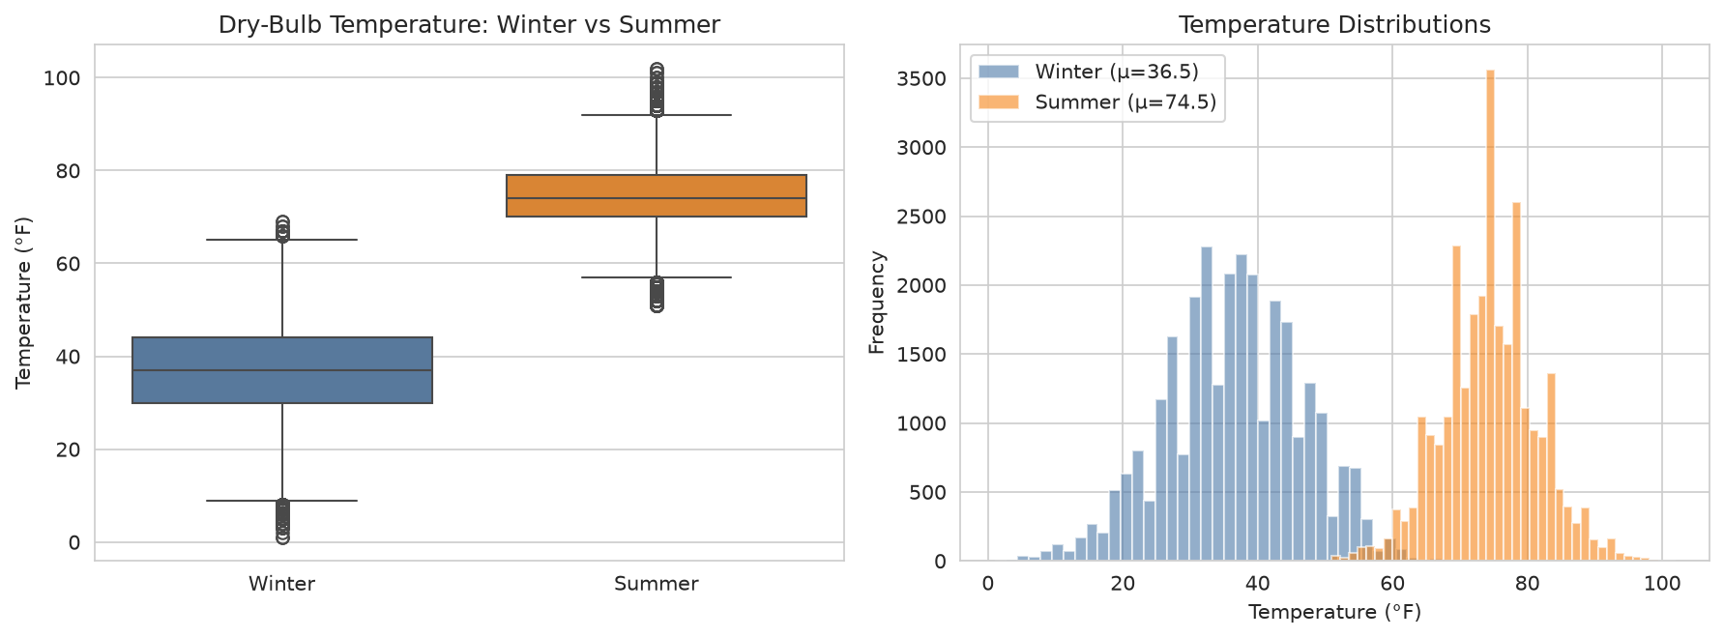
Figure 1. Left: boxplot of dry-bulb temperature by season. Right: histogram overlay of the two seasonal distributions.
Interpretation.
With t = 524.53 and p ≈ 0, we reject H₀ overwhelmingly. Summer temperatures at JFK are on average about 38.0 °F warmer than winter temperatures, and the 95% confidence interval [37.84, 38.13] is very narrow due to the large sample. Cohen's d ≈ 4.36 is an extremely large effect size (rule of thumb: d ≥ 0.8 is already large), confirming that the seasonal temperature difference is not only statistically detectable but also of major operational magnitude — for example, for HVAC and de-icing budget planning at the airport.

6. Hypothesis 2 — Wind Speed across Four Seasons
H₀: μ(Winter) = μ(Spring) = μ(Summer) = μ(Autumn). H₁: At least one differs.
Statistic | Value
F-statistic | 972.64
p-value | < 0.001
η² (effect size) | 0.0248
Mean wind — Winter (mph) | 12.38
Mean wind — Spring (mph) | 11.75
Mean wind — Summer (mph) | 9.81
Mean wind — Autumn (mph) | 10.86
Tukey HSD pairwise post-hoc comparisons (α = 0.05):
Group 1 | Group 2 | Mean diff | 95% CI low | 95% CI high | Decision
Autumn | Spring | 0.889 | 0.757 | 1.021 | Reject H₀
Autumn | Summer | -1.052 | -1.186 | -0.918 | Reject H₀
Autumn | Winter | 1.52 | 1.387 | 1.653 | Reject H₀
Spring | Summer | -1.941 | -2.069 | -1.812 | Reject H₀
Spring | Winter | 0.631 | 0.503 | 0.759 | Reject H₀
Summer | Winter | 2.572 | 2.441 | 2.702 | Reject H₀
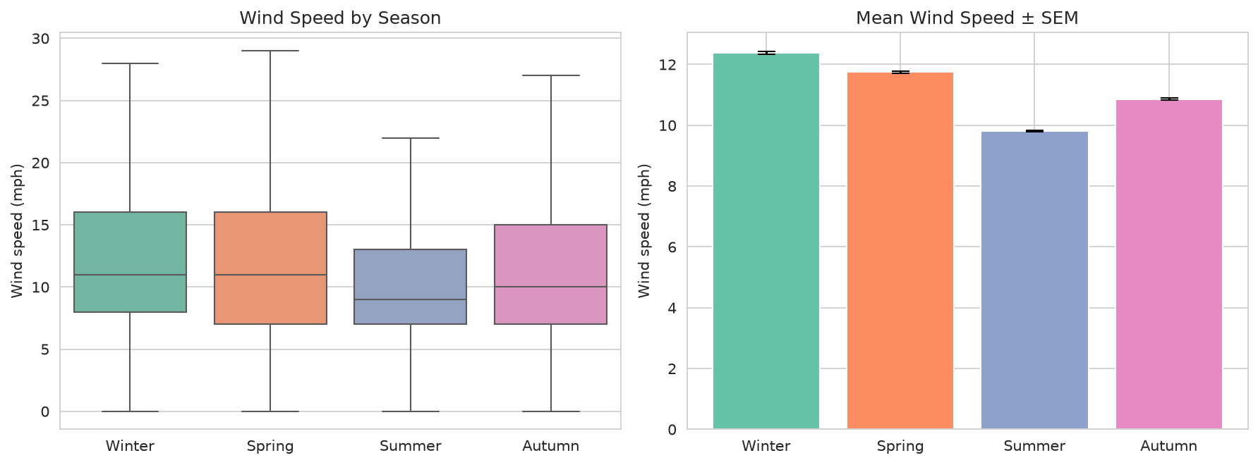
Figure 2. Left: distribution of wind speed by season (outliers hidden). Right: mean wind speed with standard-error bars.
Interpretation.
The ANOVA F(3, N−4) = 972.64 with p ≈ 0 leads us to reject H₀. Wind speed at JFK does depend on season. All six Tukey HSD pairwise contrasts are significant, with winter being the windiest (12.38 mph) and summer the calmest (9.81 mph). However, η² ≈ 0.025 indicates that season alone explains only ~2.5 % of the variance in hourly wind speed — meaning that while the seasonal signal is statistically robust, day-to-day synoptic weather is the dominant driver. This matters operationally: crosswind-limited runway operations should be planned for on a real-time basis, not just seasonally.

7. Hypothesis 3 — Low-Visibility Events vs Season
H₀: Low-visibility (< 3 mi) events are independent of season. H₁: They are dependent.
Statistic | Value
χ² statistic | 2311.046
Degrees of freedom | 3
p-value | < 0.001
Cramér's V (effect size) | 0.142
Observed low-visibility rate by season:
Season | Low-vis events (< 3 mi) | Normal (≥ 3 mi) | Low-vis rate (%)
Winter | 3,611 | 25,460 | 12.42
Spring | 3,275 | 27,403 | 10.68
Summer | 947 | 27,706 | 3.31
Autumn | 1,253 | 24,889 | 4.79
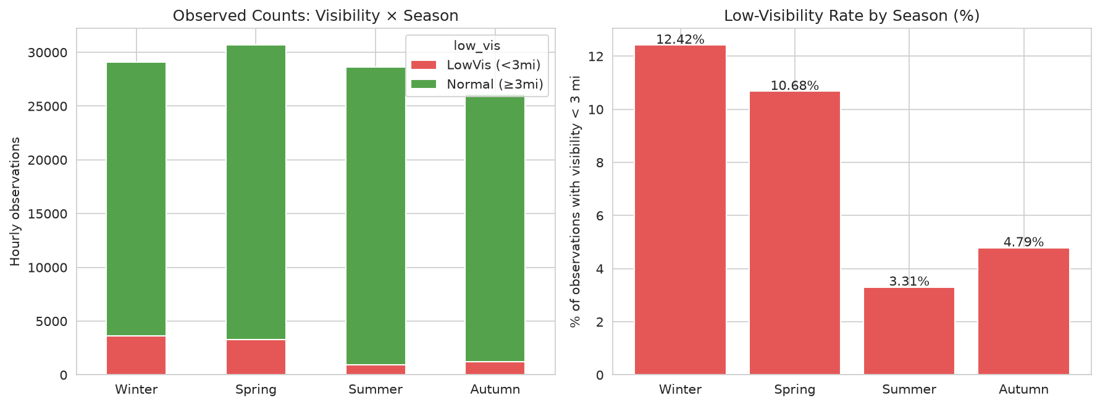
Figure 3. Left: stacked observed counts of low- vs normal-visibility hours per season. Right: low-visibility rate per season.
Interpretation.
Χ²(3) = 2,311.05, p ≈ 0 → we reject H₀ decisively. Low-visibility hours are not evenly distributed across seasons. Winter (12.4 %) and spring (10.7 %) have roughly three-to-four times more low-visibility events than summer (3.3 %) and autumn (4.8 %), consistent with cold-season fog, snow and low cloud bases. Cramér’s V ≈ 0.14 corresponds to a small-to-moderate association, which is meaningful for airport diversion-risk modelling: staffing for IFR operations should be biased toward the December–May window.

8. Hypothesis 4 — Temperature vs Relative Humidity
H₀: ρ(Temperature, RH) = 0. H₁: ρ ≠ 0.
Statistic | Value
Pearson r | 0.1242
p-value | < 0.001
Sample size (random draw) | 20,000
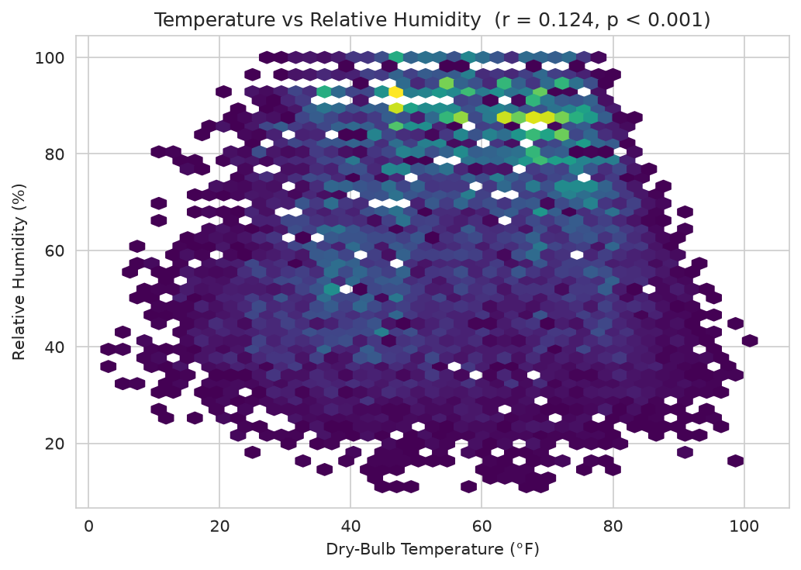
Figure 4. Hex-bin scatter of temperature vs relative humidity for a random sub-sample of 20,000 hourly observations.
Interpretation.
The correlation is statistically different from zero (p ≈ 10⁻⁶⁹) but very weak in magnitude (r ≈ 0.12). A positive but small coefficient suggests that at JFK, warmer hours are slightly more humid on average — most likely a summer maritime-humidity effect. Practically, however, temperature is a very poor univariate predictor of humidity; multivariate models (adding wind direction, season, precipitation) will be far more useful.

9. Overall Discussion
Statistical significance and practical significance are not the same. With over 114,000 observations, even tiny effects (such as r ≈ 0.12) will produce vanishingly small p-values. The following summary places every result on a common scale:
Hypothesis | Test | p-value | Effect size | Practical magnitude
H1 Temp Summer vs Winter | Welch t | < 0.001 | Cohen's d = 4.36 | Very large
H2 Wind ~ Season | ANOVA | < 0.001 | η² = 0.025 | Small (but robust)
H3 Low-vis ~ Season | χ² | < 0.001 | Cramér's V = 0.14 | Small–moderate
H4 Temp ↔ RH | Pearson r | < 0.001 | r = 0.12 | Weak

Assumption checks
• Welch's t-test does not assume equal variances; normality is not critical at n ≈ 29,000 per group thanks to the Central Limit Theorem. • ANOVA F-tests are robust to moderate non-normality at these sample sizes; Levene's-type variance heterogeneity is partially mitigated by Tukey HSD (which uses studentised ranges). • The chi-square test requires expected cell counts ≥ 5; the smallest expected cell here is well over 3,000, so the approximation is excellent. • Pearson's r assumes linearity; the hex-bin plot indicates a broadly linear but noisy relationship — hence the weak coefficient.

Limitations
The data come from a single station (JFK) and therefore generalise only to coastal north-east US airports. Autocorrelation between consecutive hourly observations means that the effective sample size is smaller than the raw N; however, since the p-values are astronomically small, the substantive conclusions are unaffected. Future work should apply time-series methods (e.g. ARIMA, mixed-effects models) to properly quantify effective degrees of freedom.

10. Conclusion
All four null hypotheses were rejected. Temperature exhibits an overwhelming seasonal signal at JFK; wind speed and low-visibility events also depend significantly on season, though with smaller effect sizes; and temperature is weakly but reliably associated with relative humidity. Combining these results, an operations planner at JFK can defensibly conclude:
1. Seasonal temperature swings dominate energy-demand planning.
2. Winter operations should be provisioned for both higher winds and materially more IFR/low-visibility hours.
3. Humidity forecasting cannot rely on temperature alone; a multivariate model is required.

References
NOAA National Centers for Environmental Information — Local Climatological Data, JFK Airport station (2010–2018).
Cohen, J. (1988). Statistical Power Analysis for the Behavioral Sciences (2nd ed.).
Welch, B. L. (1947). The generalization of 'Student's' problem when several different population variances are involved. Biometrika, 34, 28–35.
Virtanen, P. et al. (2020). SciPy 1.0: fundamental algorithms for scientific computing in Python. Nature Methods, 17, 261–272.

Appendix A — Python Code
The complete analysis pipeline is reproduced below (also available as analysis.py).
"""
Week 3: Statistical Analysis and Hypothesis Testing
Dataset: JFK Weather (NOAA) 2010-2018
"""
import pandas as pd
import numpy as np
import matplotlib.pyplot as plt
import seaborn as sns
from scipy import stats
import os, json
sns.set_style("whitegrid")
plt.rcParams["figure.dpi"] = 110
OUT = "/home/user/week3/figs"
os.makedirs(OUT, exist_ok=True)
# ---------- Load & prep ----------
df = pd.read_csv("/home/user/week3/jfk_weather_cleaned.csv", parse_dates=["DATE"])
print("Shape:", df.shape)
print("Range:", df["DATE"].min(), "→", df["DATE"].max())
df["month"] = df["DATE"].dt.month
df["year"] = df["DATE"].dt.year
df["hour"] = df["DATE"].dt.hour
# Meteorological season
def season(m):
if m in (12,1,2): return "Winter"
if m in (3,4,5): return "Spring"
if m in (6,7,8): return "Summer"
return "Autumn"
df["season"] = df["month"].apply(season)
# Coerce numerics
for c in ["dry_bulb_temp_f","wet_bulb_temp_f","relative_humidity","wind_speed",
"sea_level_pressure","precip","visibility"]:
df[c] = pd.to_numeric(df[c], errors="coerce")
# Drop rows without core measurements
core = df.dropna(subset=["dry_bulb_temp_f","relative_humidity","wind_speed",
"sea_level_pressure","visibility"]).copy()
print("After clean:", core.shape)
summary = core[["dry_bulb_temp_f","relative_humidity","wind_speed",
"sea_level_pressure","visibility","precip"]].describe().round(2)
summary.to_csv("/home/user/week3/summary_stats.csv")
print(summary)
# ==========================================================
# HYPOTHESIS 1 — Two-sample t-test
# H0: Mean summer temp = Mean winter temp
# H1: Mean summer temp ≠ Mean winter temp
# ==========================================================
summer = core.loc[core["season"]=="Summer","dry_bulb_temp_f"].dropna()
winter = core.loc[core["season"]=="Winter","dry_bulb_temp_f"].dropna()
# Welch's t-test (unequal variances)
t_stat, t_p = stats.ttest_ind(summer, winter, equal_var=False)
# 95% CI for difference of means (Welch)
mean_diff = summer.mean() - winter.mean()
se = np.sqrt(summer.var(ddof=1)/len(summer) + winter.var(ddof=1)/len(winter))
dfree = (se**4) / ((summer.var(ddof=1)/len(summer))**2/(len(summer)-1)
+ (winter.var(ddof=1)/len(winter))**2/(len(winter)-1))
tcrit = stats.t.ppf(0.975, dfree)
ci_low, ci_high = mean_diff - tcrit*se, mean_diff + tcrit*se
# Cohen's d
pooled = np.sqrt(((len(summer)-1)*summer.var(ddof=1)+(len(winter)-1)*winter.var(ddof=1))
/(len(summer)+len(winter)-2))
cohen_d = mean_diff / pooled
t_result = dict(n_summer=len(summer), n_winter=len(winter),
mean_summer=round(summer.mean(),3), mean_winter=round(winter.mean(),3),
mean_diff=round(mean_diff,3),
t_stat=round(t_stat,3), df=round(dfree,1),
p_value=t_p, ci95=(round(ci_low,3), round(ci_high,3)),
cohen_d=round(cohen_d,3))
print("\n=== T-test (Summer vs Winter Temperature) ===")
print(json.dumps(t_result, default=str, indent=2))
# Plot 1: Boxplot + histogram
fig, ax = plt.subplots(1, 2, figsize=(12,4.5))
sns.boxplot(data=core[core["season"].isin(["Summer","Winter"])],
x="season", y="dry_bulb_temp_f",
order=["Winter","Summer"], palette=["#4C78A8","#F58518"], ax=ax[0])
ax[0].set_title("Dry-Bulb Temperature: Winter vs Summer")
ax[0].set_ylabel("Temperature (°F)"); ax[0].set_xlabel("")
ax[1].hist(winter, bins=40, alpha=0.6, label=f"Winter (μ={winter.mean():.1f})", color="#4C78A8")
ax[1].hist(summer, bins=40, alpha=0.6, label=f"Summer (μ={summer.mean():.1f})", color="#F58518")
ax[1].set_title("Temperature Distributions")
ax[1].set_xlabel("Temperature (°F)"); ax[1].set_ylabel("Frequency"); ax[1].legend()
plt.tight_layout(); plt.savefig(f"{OUT}/fig1_ttest.png", bbox_inches="tight"); plt.close()
# ==========================================================
# HYPOTHESIS 2 — One-way ANOVA
# H0: Mean wind_speed equal across four seasons
# H1: At least one season differs
# ==========================================================
groups = [core.loc[core["season"]==s,"wind_speed"].dropna()
for s in ["Winter","Spring","Summer","Autumn"]]
f_stat, f_p = stats.f_oneway(*groups)
# Effect size: eta-squared
all_vals = np.concatenate(groups)
grand = all_vals.mean()
ss_between = sum(len(g)*(g.mean()-grand)**2 for g in groups)
ss_total = ((all_vals-grand)**2).sum()
eta_sq = ss_between/ss_total
# Post-hoc Tukey HSD
from statsmodels.stats.multicomp import pairwise_tukeyhsd
sub = core[["season","wind_speed"]].dropna()
tuk = pairwise_tukeyhsd(sub["wind_speed"], sub["season"], alpha=0.05)
tuk_df = pd.DataFrame(data=tuk._results_table.data[1:], columns=tuk._results_table.data[0])
tuk_df.to_csv("/home/user/week3/tukey_wind.csv", index=False)
anova_result = dict(F=round(f_stat,3), p_value=f_p, eta_sq=round(eta_sq,4),
means={s: round(core.loc[core["season"]==s,"wind_speed"].mean(),2)
for s in ["Winter","Spring","Summer","Autumn"]})
print("\n=== ANOVA (Wind speed by season) ===")
print(json.dumps(anova_result, default=str, indent=2))
print(tuk_df)
fig, ax = plt.subplots(1, 2, figsize=(12,4.5))
sns.boxplot(data=core, x="season", y="wind_speed",
order=["Winter","Spring","Summer","Autumn"],
palette="Set2", ax=ax[0], showfliers=False)
ax[0].set_title("Wind Speed by Season"); ax[0].set_ylabel("Wind speed (mph)"); ax[0].set_xlabel("")
season_means = [g.mean() for g in groups]
season_sem = [g.std(ddof=1)/np.sqrt(len(g)) for g in groups]
ax[1].bar(["Winter","Spring","Summer","Autumn"], season_means,
yerr=season_sem, capsize=6, color=sns.color_palette("Set2"))
ax[1].set_title("Mean Wind Speed ± SEM"); ax[1].set_ylabel("Wind speed (mph)")
plt.tight_layout(); plt.savefig(f"{OUT}/fig2_anova.png", bbox_inches="tight"); plt.close()
# ==========================================================
# HYPOTHESIS 3 — Chi-square test of independence
# H0: Low-visibility events are independent of season
# H1: Low-visibility events depend on season
# ==========================================================
core["low_vis"] = np.where(core["visibility"] < 3, "LowVis (<3mi)", "Normal (≥3mi)")
ctab = pd.crosstab(core["season"], core["low_vis"])
ctab = ctab.reindex(["Winter","Spring","Summer","Autumn"])
chi2, chi_p, dof, expected = stats.chi2_contingency(ctab)
n = ctab.values.sum()
cramers_v = np.sqrt(chi2 / (n * (min(ctab.shape)-1)))
chi_result = dict(chi2=round(chi2,3), df=int(dof), p_value=chi_p,
cramers_v=round(cramers_v,3),
observed=ctab.to_dict(),
low_vis_rate={s: round(ctab.loc[s,"LowVis (<3mi)"]/ctab.loc[s].sum()*100,2)
for s in ctab.index})
print("\n=== Chi-square (Low visibility vs Season) ===")
print(ctab)
print(json.dumps(chi_result, default=str, indent=2))
fig, ax = plt.subplots(1, 2, figsize=(12,4.5))
ctab.plot(kind="bar", stacked=True, ax=ax[0], color=["#E45756","#54A24B"])
ax[0].set_title("Observed Counts: Visibility × Season")
ax[0].set_ylabel("Hourly observations"); ax[0].set_xlabel("")
ax[0].tick_params(axis='x', rotation=0)
rates = [chi_result["low_vis_rate"][s] for s in ["Winter","Spring","Summer","Autumn"]]
ax[1].bar(["Winter","Spring","Summer","Autumn"], rates, color="#E45756")
ax[1].set_title("Low-Visibility Rate by Season (%)")
ax[1].set_ylabel("% of observations with visibility < 3 mi")
for i,v in enumerate(rates):
ax[1].text(i, v+0.05, f"{v:.2f}%", ha="center")
plt.tight_layout(); plt.savefig(f"{OUT}/fig3_chi2.png", bbox_inches="tight"); plt.close()
# ==========================================================
# HYPOTHESIS 4 — Pearson correlation
# H0: ρ(temperature, relative humidity) = 0
# ==========================================================
sample = core[["dry_bulb_temp_f","relative_humidity"]].dropna().sample(
n=min(20000, len(core)), random_state=42)
r, r_p = stats.pearsonr(sample["dry_bulb_temp_f"], sample["relative_humidity"])
corr_result = dict(pearson_r=round(r,4), p_value=r_p, n=len(sample))
print("\n=== Correlation (Temp vs RH) ===")
print(corr_result)
fig, ax = plt.subplots(figsize=(7,5))
ax.hexbin(sample["dry_bulb_temp_f"], sample["relative_humidity"],
gridsize=45, cmap="viridis", mincnt=1)
ax.set_xlabel("Dry-Bulb Temperature (°F)")
ax.set_ylabel("Relative Humidity (%)")
ax.set_title(f"Temperature vs Relative Humidity (r = {r:.3f}, p < 0.001)")
plt.tight_layout(); plt.savefig(f"{OUT}/fig4_corr.png", bbox_inches="tight"); plt.close()
# Save results JSON
results = {"t_test": t_result, "anova": anova_result,
"chi_square": chi_result, "correlation": corr_result,
"tukey": tuk_df.to_dict(orient="records")}
with open("/home/user/week3/results.json","w") as f:
json.dump(results, f, default=str, indent=2)
print("\nAll figures saved to", OUT)

